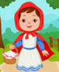
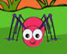
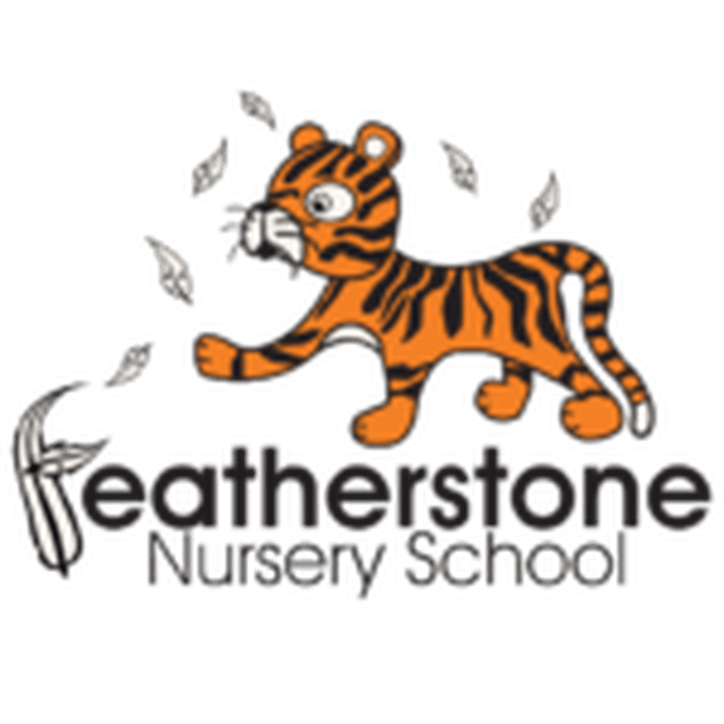

Spring 1 - Traditional Tales and Rhymes
Federation of Osborne and Featherstone Nursery Schools Curriculum Guide for Parents and Carers
2 Year Olds | 3 Year Olds | 4 Year Olds
Key Activities:  Exploring language and naming objects in their environments. Children will learn to name body parts and move to the rhymes and remember actions.  They will talk about animals, have their favourites and make sounds. They will remember their favourite rhymes and begin to explore number through rhymes. | Key Activities:  Children will be encouraged to talk about Nursery and use the correct naming words. Children will make friendships and talk about their friends. How can we be a good friend? Children will listen to longer stories and talk about the events.  Children will start to compare sizes—length, height, weight | Key Activities:  Children will have favourite stories and will be exposed to new stories. They will take on a role in a story and understand how the character feels and the events in the story.  Children will plant seed sand learn how to care for plants. They will take part in cooking activities and learn about the ingredients.
Core books to read:  Singing lots of nursery rhymes and using books to support.  Incy Wincy Spider, Twinkle, twinkle Little Star, Old Mac Donald, The Wheels on the Bus | Core books to read:  Goldilocks and the Three Bears - various versions  The Gingerbread Man, The Three Billy Goats Gruff, The Three Little Pigs, aspers Beanstalk by Nick Butterworth | Core books to read:  Little Red Riding Hood, Jack and the Beanstalk, The Little Red Hen, Harvey the Gardener by Lars Clinting  Reread favourite stories too! Goldilocks, The Gruffalo, Zog
Important words to learn:  Building vocabulary—naming (nouns) words inside and outside  Animal names—tiger, dog, elephant, cat  Begin to use positional language—on, off, up, down  Begin to say numbers 1 to 5. Use bigger / smaller | Important words to learn:  Start to compare—who is running faster, slower, which is the tallest, smallest, biggest, shortest. Which jug is full or empty? Sequence events—first, next, after, then.  Repeat words from books “I will huff and puff and blow your house down!” | Important words to learn:  Story words– once upon a time, beginning, middle, end, finally, before, character, setting.  Describe settings with your child (where the story happens) -  Deep, dark forest, hot, sunny desert, icy, cold water.
How can you help at home? Sing lot s of nursery rhymes! Share favourites and repeat the actions. Look at books with animals inside, visit the park, nature centre or zoo to name the animals. Count together. | How can you help at home? Share traditional stories together, read and watch. Act out the stories together—who will be the wolf?! Compare together—have a running race—who is faster? Who is taller? | How can you help at home? Talk about the events in the story and encourage your child to tell the story. Read every day - read favourite stories and new ones! Share cooking sessions at home—talk about ingredients and tastes. Count 10 objects!

